ADDING FRACTIONS

QUESTION DIAGRAM REWRITTEN WITH ANSWER
LIKE DENOMINATORS
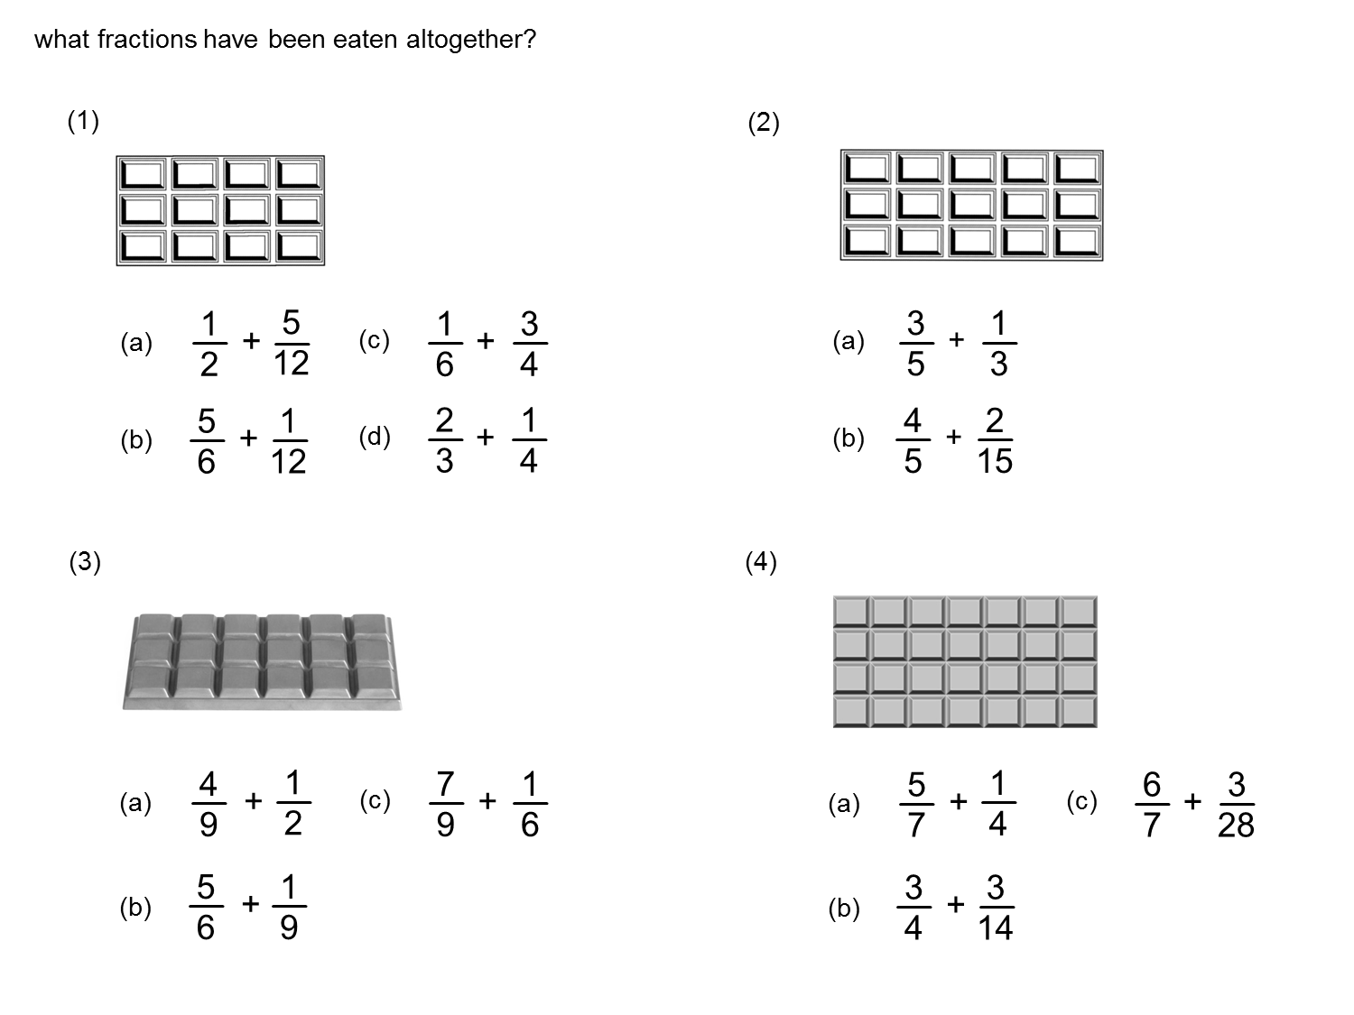
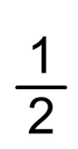
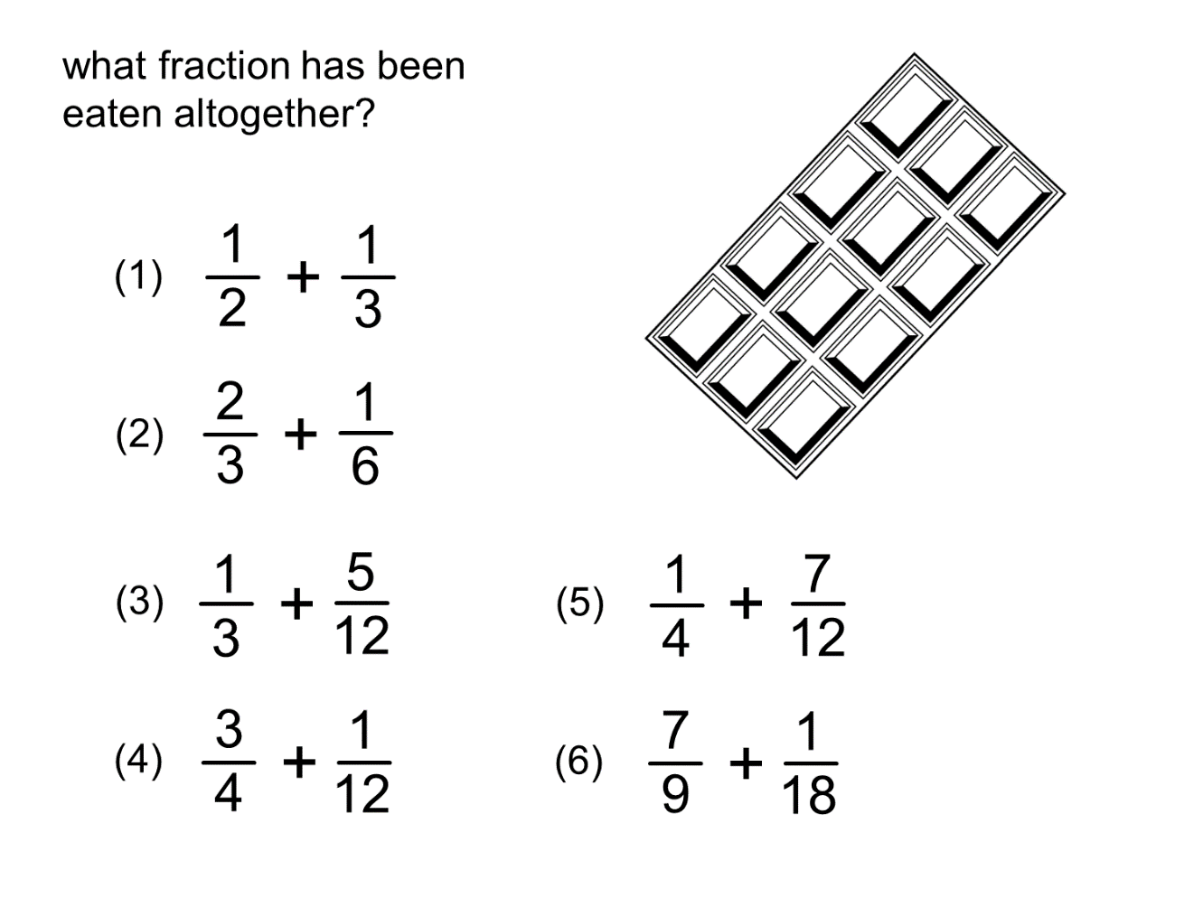
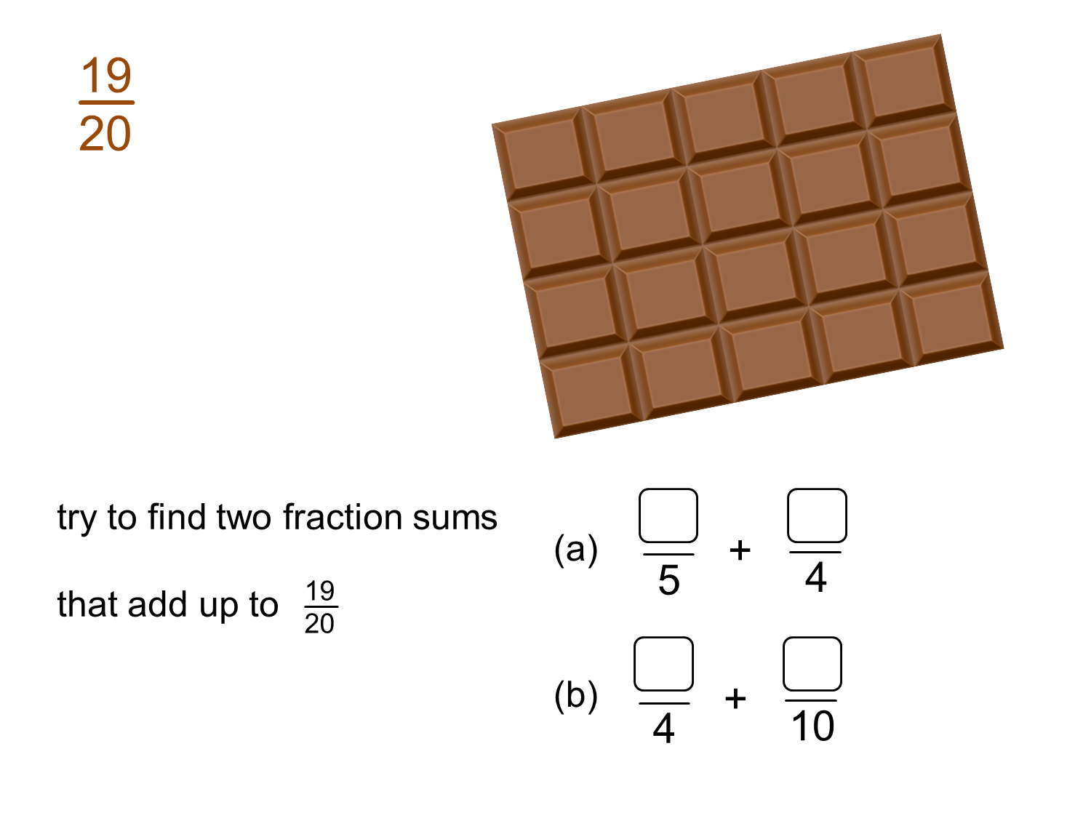
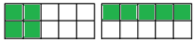
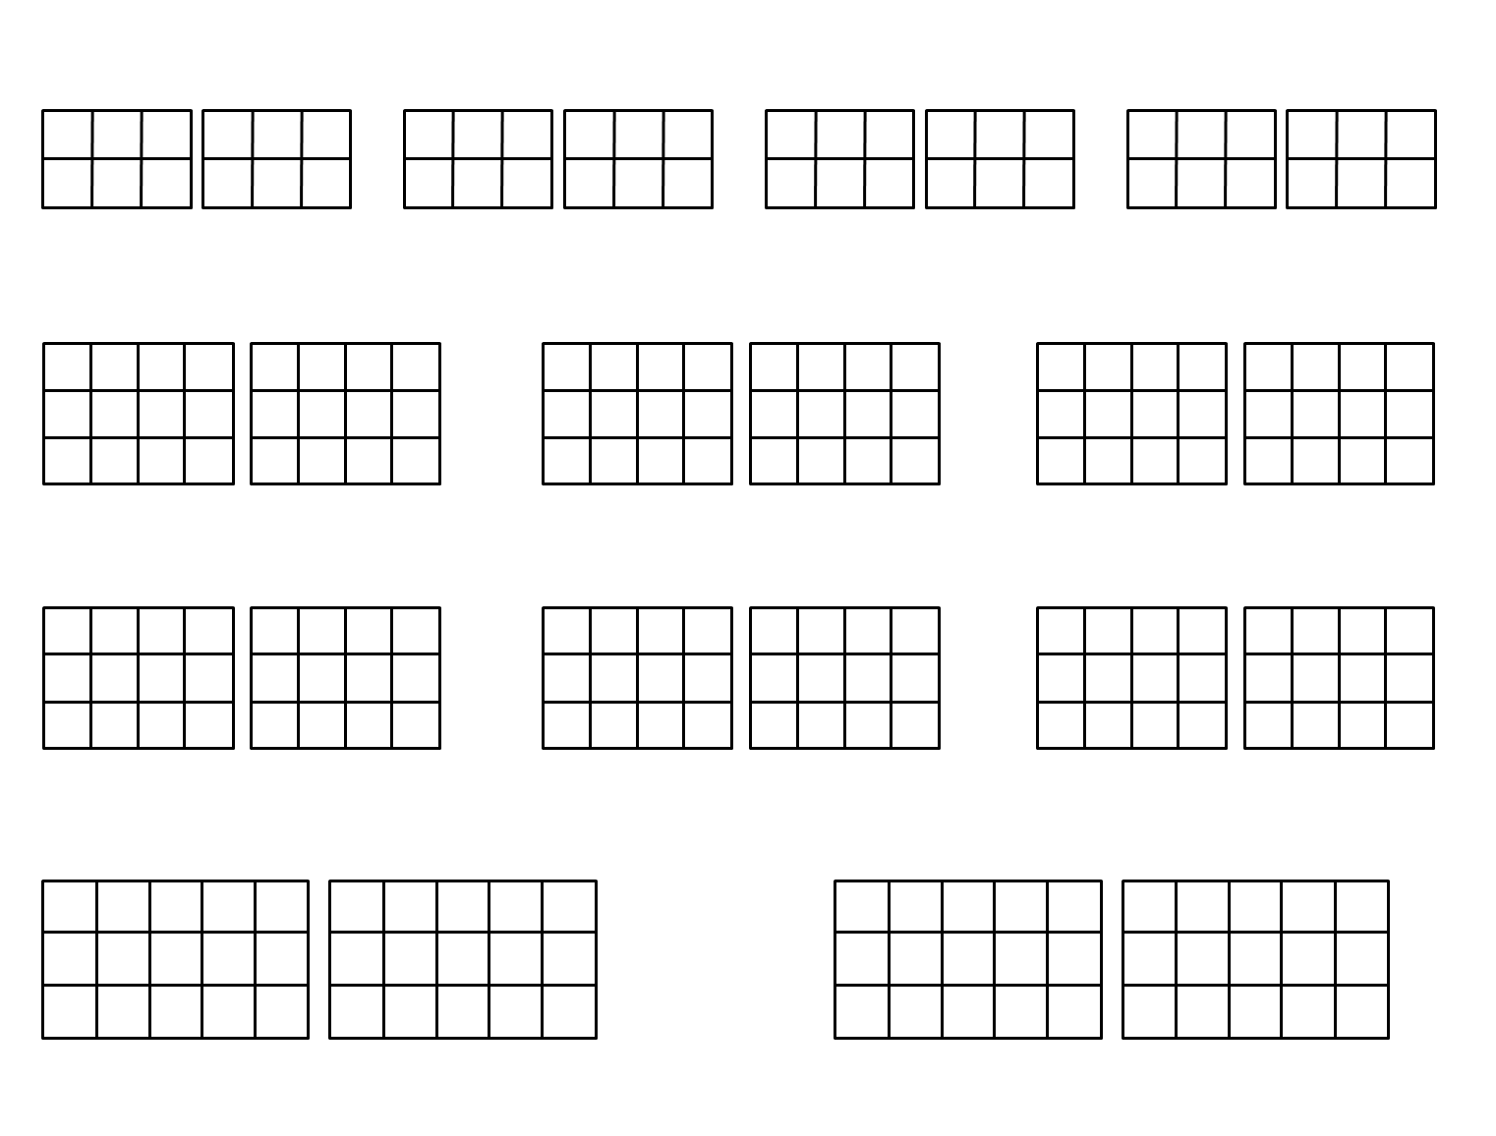

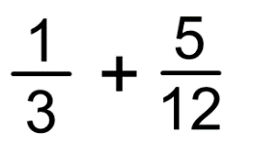
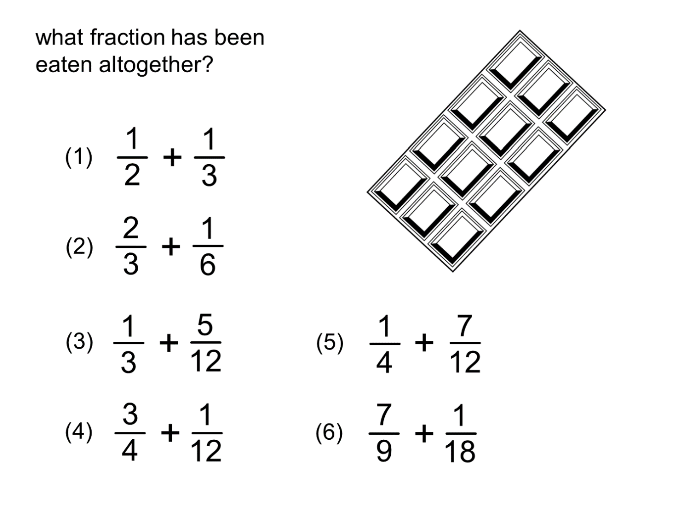
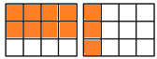
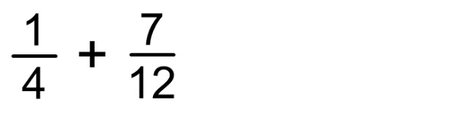

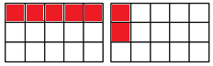

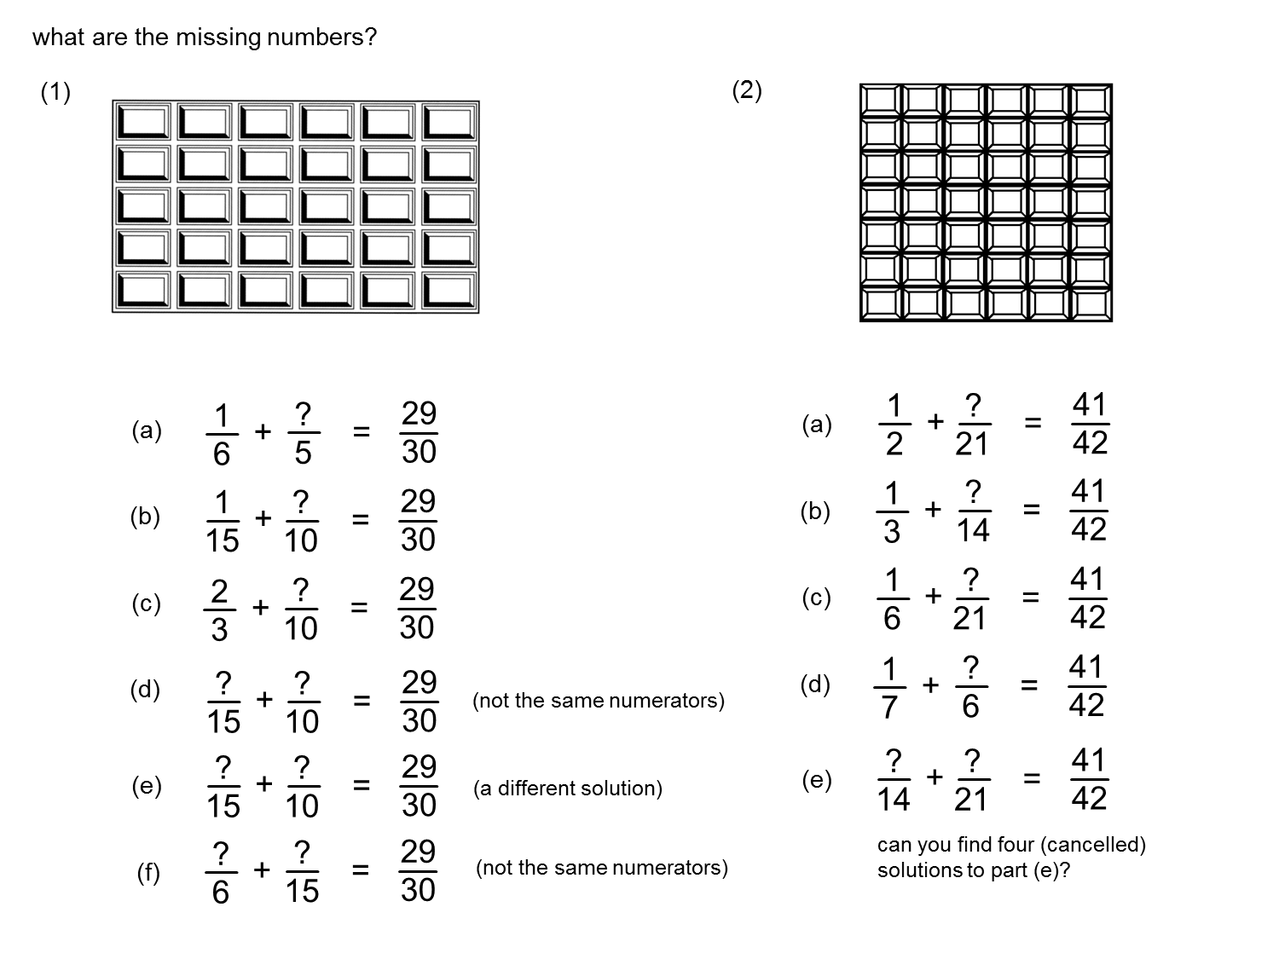

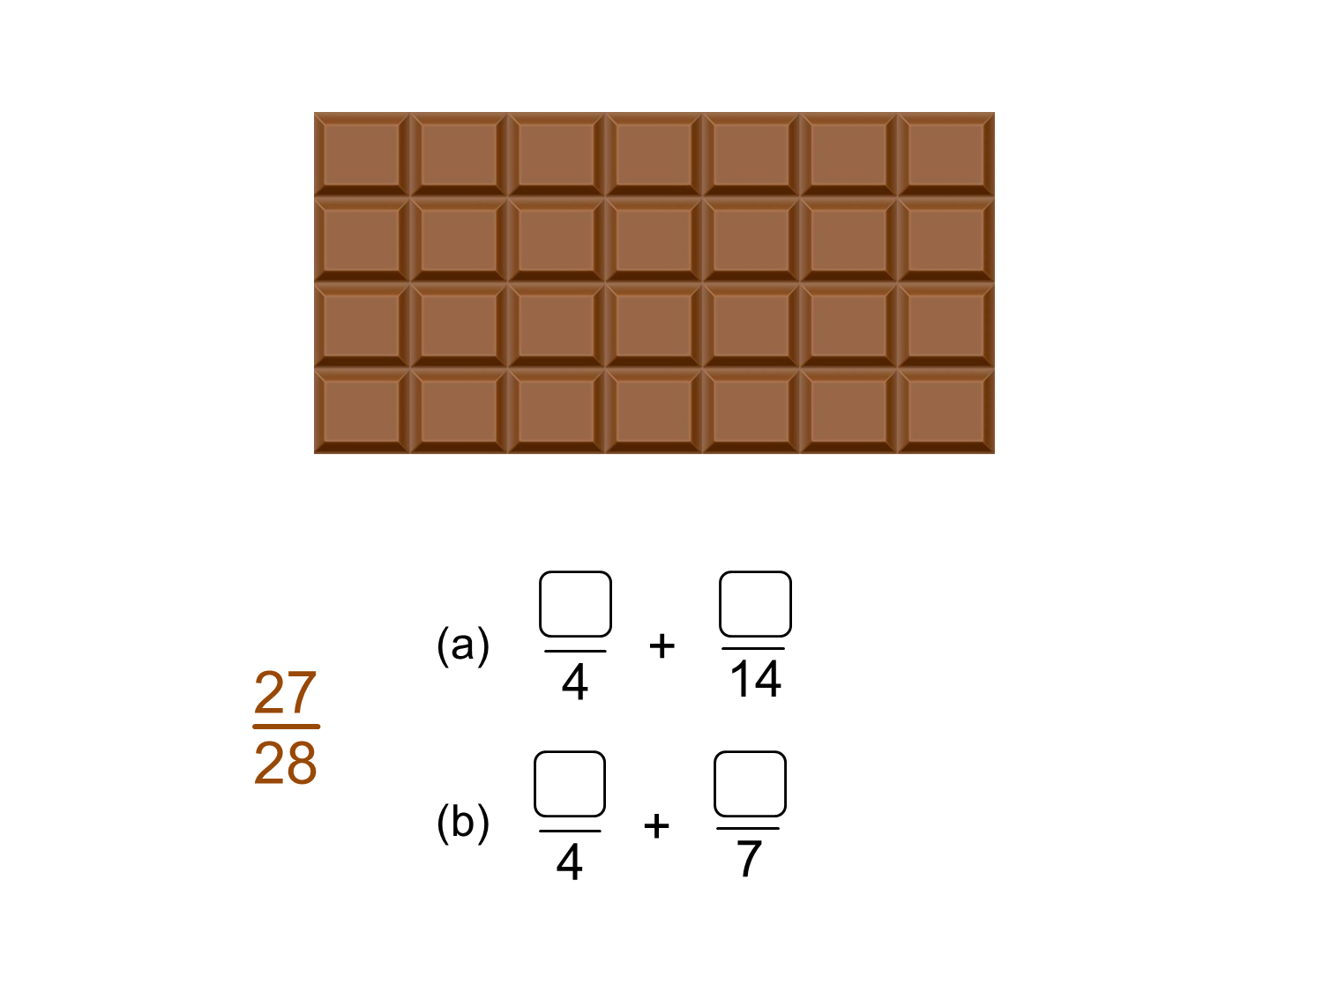

ADD THE FRACTIONS BY DRAWING AND SHADING IN THE PROVIDED GRIDS IN YOUR JOTTER.
DRAW A NEW PAIR OF GRIDS FOR EACH QUESTION.
BY USING THE GRID (OR USING ANY OTHER RELEVANT METHOD) FIND THE MISSING NUMBERS

